Ohio Polio Network Newsletter
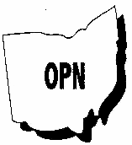

MERRY CHRISTMAS
&
HAPPY NEW YEAR
2007
Winter Issue 2006
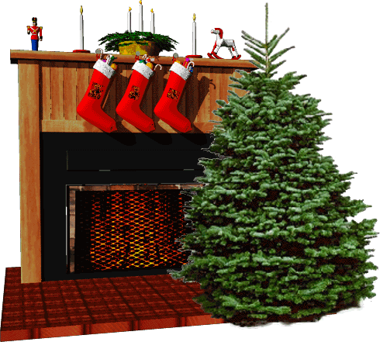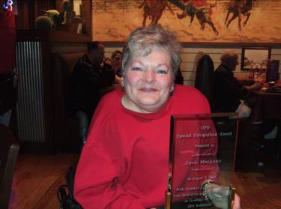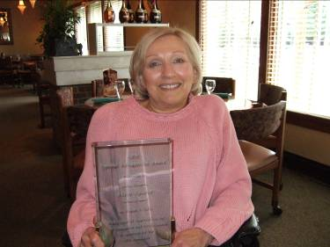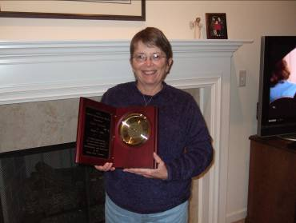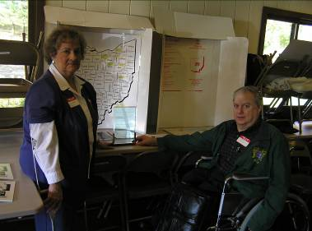
In this issue

OPN Awards 1-2
President’s Message 3
Post-Polio Basics 4-6
Winnie Walker Picnic 7
Websites 8
OPN & PPS Groups 9

2006 OPN SPECIAL RECOGNITION AWARDS
Joyce Metheny
Alice Sporar
Teddi Gideon
Winnie Walker



2006 OPN SPECIAL RECOGNITION AWARDS

OPN has recognized four individuals who have dedicated themselves to the Ohio post-polio community with excellent service by presenting them with OPN Special Recognition Awards. Joyce Metheny and Alice Sporar have been co-editors of the OPN Newsletter for many years. They also organized and led the last OPN Conference. Alice is also the group leader of the Greater Cleveland Post-Ppolio Support Group. Teddi Gideon has been the Secretary and the Treasurer of OPN for many years. She has also worked on OPN Conferences and continues to assist in the distribution of the OPN newsletter. Winnie Walker is the group leader of the HELPS Post-Polio Support Group and has organized the annual picnic for the post-polio community and their families for many years. Congratulations Joyce, Alice, Teddi and Winnie! We thank each of you for your excellent service and dedication to the post-polio community.

RENEWAL NOTICE
Please note that September is our Renewal Month. Take a moment to check your mailing label. If the Expiration Date is 09/06, please renew your membership. If the Date is 09/07 or later, your membership is current.

President’s Message
Pat Kelly

This is our Christmas Issue. As I was putting this together, I thought of Christmas in its truest sense, celebrating the birth of Christ. This is a time to be with friends and family and a time for giving. As we approach the New Year, this is also a time to reflect and one of beginning. Therefore, the concepts of both reflection and beginning are included in this issue.

In the spirit of reflecting on our organization and its members, OPN has recognized four individuals who have dedicated themselves to the Ohio post-polio community with excellent service and by presented them with OPN Special Recognition Awards. (See article in this issue)

We have had a change in plans regarding the newsletter. As you can see, I have published this newsletter. I have learned a lot in the process. It is not an easy job. I am happy to say that Joyce Metheny and Alice Sporar have agreed to continue to be co-editors of the newsletter beginning with the next issue. I would encourage you, the members of OPN, to support them by submitting articles for consideration in the newsletter.
With the new year it is a time to consider the basics of post-polio. This information as published by the National Institutes of Health is provided in this issue. This is provided for three reasons. First, in understanding post-polio, it is the place to start. All research of the many facets of post-polio stem from here. Second, as we have found in conferences of the past, there are always people who are not aware of this basic information. Third, it provides us with information that we can bring to our family doctors who may not be familiar with post-polio syndrome.

For members who have access to the internet, a website page is provided to extend the benefit of the newsletter. To print all of the information available is not possible. In addition, without the permission of the author or owner of the information, we cannot publish it. Providing links to the internet allows you to learn even more. One of the websites listed, Brain Physiology in Polio Survivors a study by the National Institute of Neurological Disorders and Stroke (NINDS) is the site of a clinical trial that appears to be currently recruiting patients. I have e-mailed them to confirm the trials status. However, I do not have a reply at this time.

Our next OPN Board Meeting is tentatively scheduled for March 31, 2007 at the Westerville Library. All are welcome to attend. On behalf of the OPN Board, Janice and I would like to wish each of you and your families a Merry Christmas and a Happy, Healthy, New Year.

The following is the first part of the post-polio information provided by the National Institutes of Health. The second part will be in coming issue.
What is post-polio syndrome?
Post-polio syndrome (PPS) is a condition that affects polio survivors years after recovery from an initial acute attack of the poliomyelitis virus. PPS is mainly characterized by new weakening in muscles that were previously affected by the polio infection and in muscles that seemingly were unaffected. Symptoms include slowly progressive muscle weakness, unaccustomed fatigue (both generalized and muscular), and, at times, muscle atrophy. Pain from joint degeneration and increasing skeletal deformities such as scoliosis are common. Some patients experience only minor symptoms. While less common, others may develop visible muscle atrophy, or wasting.
PPS is rarely life-threatening. However, untreated respiratory muscle weakness can result in underventilation, and weakness in swallowing muscles can result in aspiration pneumonia.
The severity of residual weakness and disability after acute poliomyelitis tends to predict the development of PPS. Patients who had minimal symptoms from the original illness will most likely experience only mild PPS symptoms. People originally hit hard by the poliovirus and who attained a greater recovery may develop a more severe case of PPS with a greater loss of muscle function and more severe fatigue. It should be noted that many polio survivors were too young to remember the severity of their original illness and that accurate memory fades over time.
According to estimates by the National Center for Health Statistics, more than 440,000 polio survivors in the United States may be at risk for PPS. Researchers are unable to establish a firm prevalence rate, but they estimate that the condition affects 25 percent to 50 percent of these survivors, or possibly as many as 60 percent, depending on how the disorder is defined and which study is quoted.
Patients diagnosed with PPS sometimes are concerned that they are having polio again and are contagious to others. Studies have shown that this does not happen.
What causes PPS?
The cause is unknown. However, the new weakness of PPS appears to be related to the degeneration of individual nerve terminals in the motor units that remain after the initial illness. A motor unit is a nerve cell (or neuron) and the muscle fibers it activates. The poliovirus attacks specific neurons in the brainstem and the anterior horn cells of the spinal cord. In an effort to compensate for the loss of these neurons, ones that survive sprout new nerve

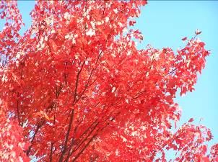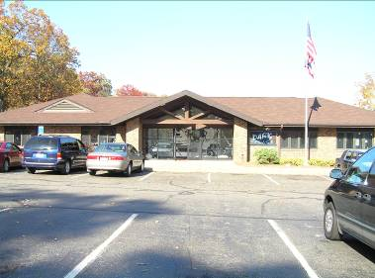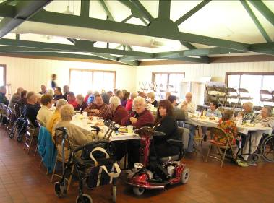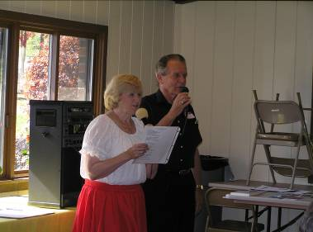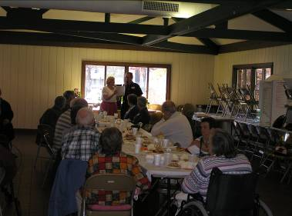
Winnie Walker Picnic 2006

The Winnie Walker Picnic was held at Tuscora Park in New Philadelphia, Ohio on a very nice Fall day. For this gathering of the post-polio community and their families, more than 40 attended the picnic, a delicious catered steak and chicken dinner with all the fixin’s and desserts. Drawings were held for prizes and everyone left with a gift donated by those attending. Robert Newton, a gifted wood carver and teacher donated several handmade Christmas ornaments. OPN donated several CD’s from the last International Post-Polio Conference. There was a table of information on post-polio and information from the support groups OPN had a display with an Ohio map, created by OPN Board member Gretchen Estreicher. It showed the locations of the support groups. Two of the HELPS Support Group members who aided Winnie Walker in this event are Anna Rufenacht and Gloria Jones. There was entertainment and singing and games. The Picnic was very successful. Thanks to Winnie and her team!
Post-Polio Websites

http://www.geocities.com/Heartland/Ranch/5212/poliopeople.html

This page is dedicated to all Polio survivors famous or not, many who are now facing the second half of their lives with a condition known as Post Polio Syndrome...unfair as that is... and are joined by others who also had Polio, but who are just a little more recognizable...

http://www.cloudnet.com/~edrbsass/poliohistorypage.htm

a site published by Edmund J. Sass, Ed. D. There is a lot of information at this site. It has much more than just history.

http://www.postpoliobransongoers.com/

Friends Around the World Through Post Polio There is an annual gathering in Branson, MO in June the weekend before Father’s Day. This year they had members from 12 states. This is a site to see.

http://www.ninds.nih.gov/disorders/post_polio/post_polio.htm

National Institutes of Health\post-polio

http://clinicaltrials.gov/ct/show/NCT00080600;jsessionid=BC83A10221286054D4D5DFF04BEEF569?order=1

Brain Physiology in Polio Survivors a study by the National Institute of Neurological Disorders and Stroke (NINDS)

http://www.washingtonpost.com/wp-dyn/content/article/2006/11/18/AR2006111800951.html

Obituary story of Nancy Orrison who had polio when she was 2 years old about her life which changed when a relative approached an auto dealer in 1950 and had a novel device installed, hand controls.
------------------------------------------------------------------------------------------------------------

Kofi Annan, U.N.Secretary General (from his farewell speech) Dec 2006
“It has been one of my guiding principles as Secretary-General to get them to help achieve U.N. aims -- for instance through the Global Compact with international business, which I initiated in 1999, or in the worldwide fight against polio, which I hope is now in its final chapter, thanks to a wonderful partnership between the U.N. family, the U.S. Centers for Disease Control and -- crucially -- Rotary International.”
OHIO POLIO NETWORK BOARD

President | Vice-President | Secretary | Treasurer
Patrick Kelly | Joan Prior | Jo Ellen Bartow | Fran Willemsen
Marietta, OH | Powell, OH | Stow, OH | Stow, OH
(740) 374-0538 | (614) 888-5863 | (330) 688-7384 | (330) 688-4862
pkelly03@sprynet.com
Support Group Liaison | OPN Board | OPN Board
Patricia L. Novak | Chic Carlson | Gretchen Estreicher
Oak Harbor, OH | Akron, OH | Cincinnati, OH
(419) 898-3130 | (330) 864-8056 | (513) 574-1192
OPN Advisory Board | OPN Advisory Board | OPN Advisory Board | OPN Advisory Board
Frank Craig | Dave Livingston | Margaret Meyer | Greg Nemunaitis, MD
Akron, OH | N. Ridgeville, OH | Mentor, OH | MetroHealth System
(330) 836-5194 | (440) 327-0366 | (216) 401-1181 | Cleveland, OH
 |  |  | (216) 778-3850
OPN Advisory Board | OPN Advisory Board
Shirlee Sussman | Nikki Wingerson
Dayton, OH | Stow, OH
(937) 890-0205 | (330) 686-1071

POST POLIO SUPPORT GROUPS
Akron | Coal Grove | Defiance Area | Greater Cleveland
Fran Willemsen | Carolyn Melvin | Carol Thomas | Alice Sporar
(330) 688-4862 | (740) 532-7572 | (419) 497-2303 | (440) 461-7133
HELPS | Lorain | Miami Valley | Mid-Ohio Valley
New Philadelphia | County | Greater Dayton Area | Parkersburg/Vienna W.V.
Winnie Walker | Annette Will | Ed Baker | Becky White
(330) 339-6910 | (440) 365-9511 | (937) 325-8384 | (304) 295-5879
 |  |  | myridin1@juno.com
Polio Connection | Stark County | Toledo Post Polio | Wooster & Wayne
Greater Cincinnati Area | Canton Area | Connection | County
Chuck Humerickhouse | Linda Conrad | Sandy Foss | Marlene Stalnaker
(513) 777-3083 | (330) 877-2632 | (419) 893-8110 | (330) 264-6869

Membership Categories:
- Sponsor - $50.00
- Donor - $10.00 +
- Basic - $10.00
- Special Gifts
We are non-profit & tax exempt: IRS 501 (c) (3)
Public Charity 509 (a) (2)

OPN Newsletter is published quarterly. All articles for the Spring issue are due by March 1st. Please forward any letters, etc. to: Joyce Metheny, 9179 Manorford Drive, Parma Hts., OH 44130-3231. Ranger91@core.com
Please note that your mailing label contains important information regarding your membership dues.
Make checks payable to:

Ohio Polio Network
c/o
Fran Willemsen
4217 Kent Road
Stow OH 44222-4324

Name: _______________________________________

Address: _____________________________________

City:_________________________________________

State: __________________ Zip ______________

DISCLAIMER NOTICE:
THE OPINIONS EXPRESSED IN THIS PUBLICATION ARE THOSE OF THE INDIVIDUAL WRITERS AND DO NOT NECESSARILY CONSTITUTE AN ENDORSEMENT OR APPROVAL OF OPN. IF YOU ARE HAVING A MEDICAL PROBLEM, PLEASE CONSULT YOUR PHYSICIAN!!!!

Pat Kelly
104 Iroquois Drive
Marietta OH 45750

